**EXERCISE NO:1**

**DATE:14/10/2020**

**AIM:**

To print the calendar of the given month and year.

**PROGRAM:**

import calendar

month = int(input("Enter Month:"))

year = int(input("Enter year:"))

if(999<year<10000):

if(1<=month<=12):

print(calendar.month(year,month))

else:

print("Invalid input")

else:

print("Invalid input")

**LINK:** <http://103.53.53.18/mod/vpl/forms/edit.php?id=229&userid=1695>

**OUTPUT:**

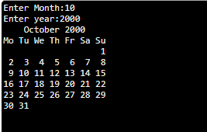

**RESULT:**

Thus the calendar is printed for the given month and year.